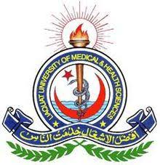
Office of Research Innovation & Commercialization
Medical Research Center
Liaquat University of medical & Health sciences, Jamshoro
Research Trainings/Workshops
Full Name: ____________________________________________________________________
Institution/Department: _________________________________________________________
Email Address: _________________________________________________________________
WhatsApp Contact No.: __________________________________________________________

Please select the workshops for registration.
- 1-Day workshop on Proposal Writing, Fee Rs. 700/=
- 2-Days workshop on Research Methodology, Fee Rs. 1200/=
- 2-Days workshop on Fundamentals of SPSS, Fee Rs. 1200/=
- 1-Day workshop on Mendeley, Fee Rs. 1000/=
- 1- Day workshop on Manuscript Writing, Fee Rs. 700/=

Signature: ______________________________________________________________
Please attach the challan copy of bank draft with registration form.
Bank Details for Fee submission:
National Bank of Pakistan
Account Title: DIRECTOR ORIC
Account Number: 4135500891
IBAN: PK67NBP0131004135500891

For further details, please visit: Medical Research Center, LUMHS Jamshoro
Note: please provide your valid WhatsApp number, email ID, and check on regular basis. They will be the conduit for all communication.
PS: No lunch will be provided during workshop.

